Automatic Failure Detection

I - Talairaching.

- Method

One of the first steps in the processing of anatomical data consists in the alignment of the input images with the Talairach atlas. A 3 by 4 transform matrix is applied to the input brain, the 12 parameters indicating the shifts, rotations, scaling and shears of a linear alignment. The severe misalignment of the input brain resulting from a failure in the Talairaching is manifest by values of the transform parameters that are outside of the normal range of variation.
In order to automatically detect these failures we use the 9 components of parameter vector T corresponding to rotation and scaling (the 3 translation parameters are not taken into account) as a summary statistic, and we assume that the vectors T are distributed multivariate in a training set. The probability Pi of each parameter vector Ti can be computed given this training set, and an adequate threshold should enable the detection of unlikely transformations.

The probability of the parameter vectors Ti have been computed for 356 subjects in the Buckner data set, the resulting distribution is shown on figure 1.
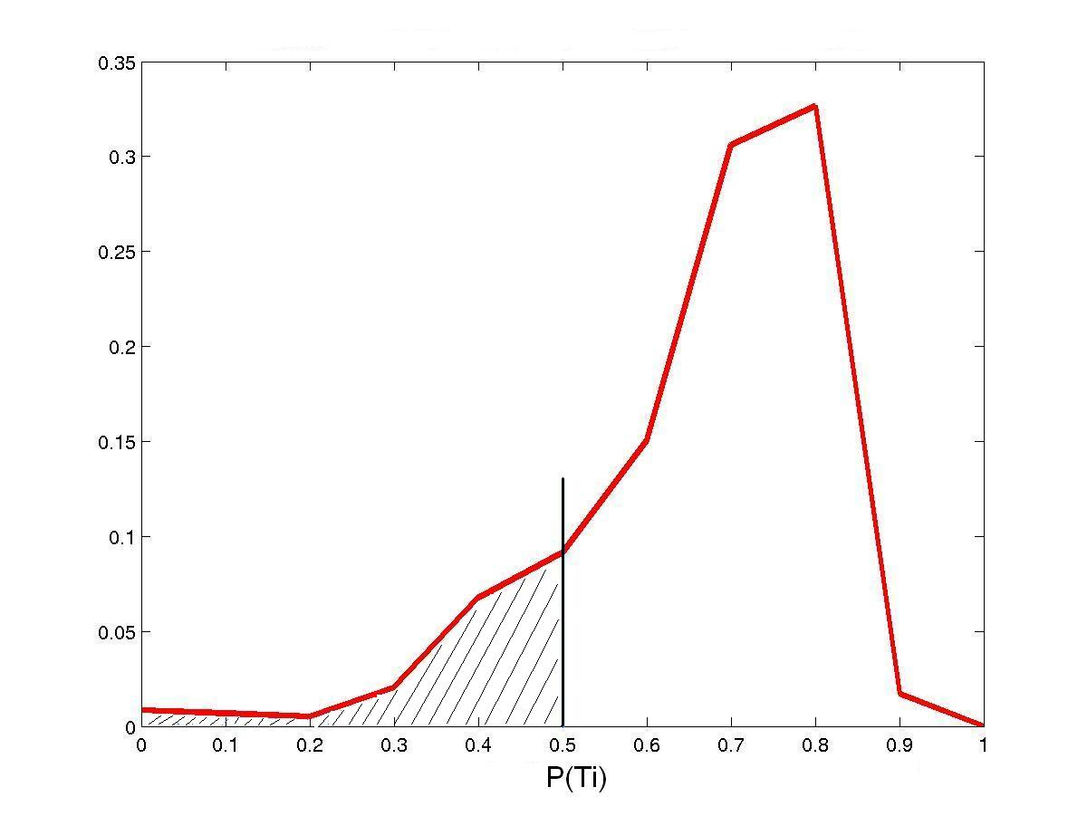
- Figure 1-
Distribution of the probabilities of the Talairach transform parameter vectors
based on 356 subjects of the Buckner data set

Given this distribution and for any new parameter Ti and its probability P(Ti | μ, Σ) (μ and Σ being respectively the mean and covariance matrix of all the parameter vectors in the training set) we can compute the area under the distribution curve (shaded area) and set a threshold for the resulting p values to detect any unlikely parameter vector. This threshold can be adjusted by the user depending on the level of correlation needed. We only need to set a lower threshold since there is no upper limit for the probability P(Ti | μ, Σ), and the area under the curve is therefore only computed on the left side of P(Ti).

- Results

By applying this method to the Buckner data set itself, and using a threshold th = 0.01 for the p values, 9 subjects are detected to have unlikely Talairach transform parameters.
The following images show sagittal, coronal and axial views of one of the Buckner subjects that is clearly misaligned:

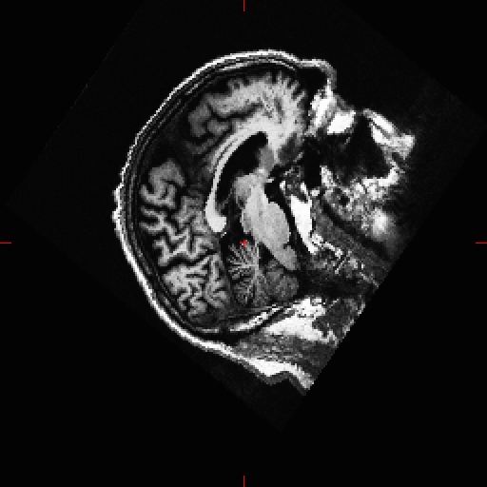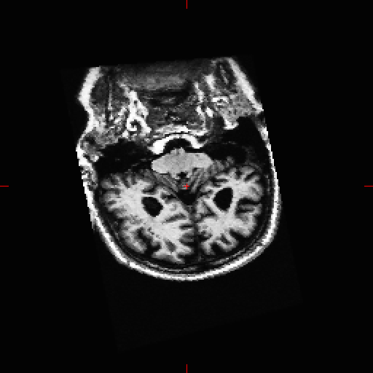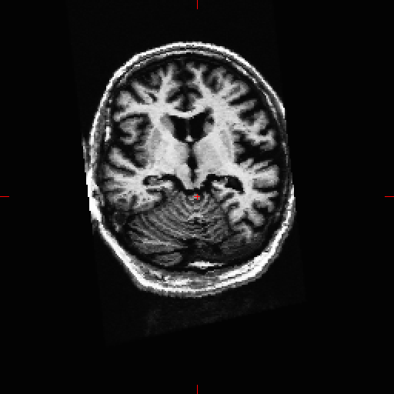

-Figure 2-
Sagittal, coronal and axial views of the subject 031014_12497-2
misaligned in the Talairach space. (p value = 0.00169)

II – B1 bias field correction

- Method

The B1 bias across the entire volume is estimated by measuring the variations in the white matter intensity. Likely white matter points are chosen based on their location in the Talairach space, their intensity, as well as the local neighborhood intensities. The effects of the bias field are then removed by dividing each voxel’s intensity by the estimated bias field at that location.

To check if the chosen control points actually belong to the white matter, we use the subcortical atlas to compute the probability for these points to be in the white matter. Because even one bad control points can cause the bias correction to fail, the minimum of these probabilities is chosen as a test statistic.

III – White matter segmentation

- Method

In the white matter (WM) segmentation of the surface-based stream, each voxel is classified as either WM or not WM. In the volume-based labeling, the WM voxels are detected and labeled. The consistency between the two streams can then be checked by measuring the overlap of the two resulting WM volumes with a Dice coefficient. For abnormally low Dice coefficient, the WM segmentation process is likely to have failed in either the volume-based or the surface-based method.

This Dice coefficient has been computed for 591 subjects in the Buckner Training set and the resulting distribution in shown on Figure 3. This distribution shows that the average overlap between the two methods is about 85 %. Because structures such as the brain stem have a different label than the white matter, the overlap is generally lower than 90%.
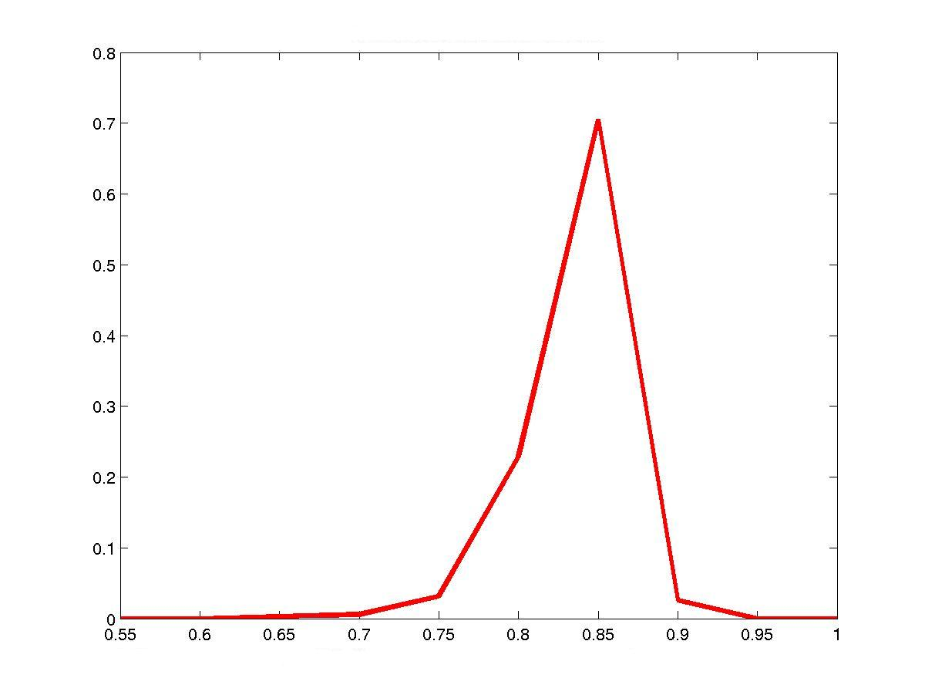
- Figure 3 -
Distribution of the Dice coefficient measuring the overlap of the white matter volumes defined by the volume-based and the surface-based methods based on 591 subjects from the Buckner data set.

Here again, p-values corresponding to the area under the distribution curve are computed. Note that only the lower threshold is needed since the complete overlap of the two white matter volumes never occurs and the Dice coefficient can be as high as we want.

- Results

A low Dice coefficient can be due to a wrong segmentation in one of the two streams. The computation of the Dice coefficient for the Buckner data set allows the detection of 9 subjects having a p value lower than the threshold th = 0.01 (a p value of 0.01 corresponds to a Dice coefficient of about 0.7).

The following images show subjects from the Buckner data set. The first subject (a) has a normal Dice coefficient (d=0.798 ) and a good white matter segmentation, while subjects b and c have a particularly low Dice coefficients (resp. 0.0010 and 0.6824) and obviously wrong WM segmentations:

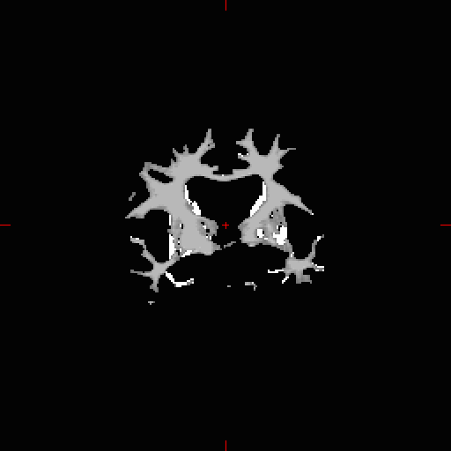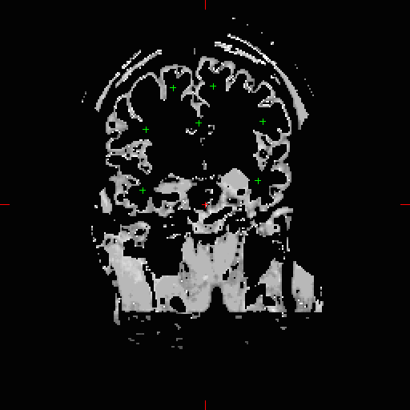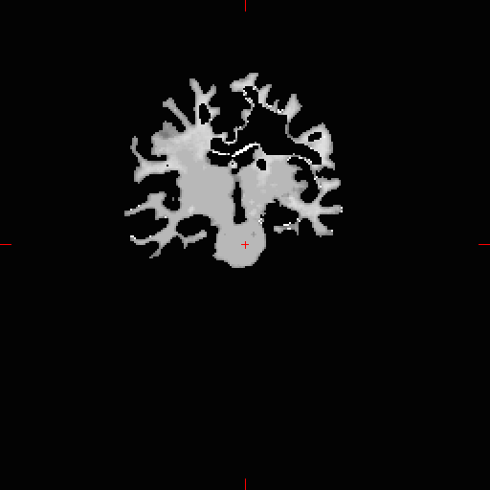
- a - - b - - c -

- Figure 4 -
a) Normal subject (010125_vc6088) – b) and c) Two subjects (021016_9044 and 021126_5079)
where the low Dice coefficients revealed failures in the white matter segmentation process.

IV – Cutting Planes

- Method

In the surface-based stream, cutting planes are chosen to separate the left and right hemispheres from each other as well as to remove the cerebellum and the brain stem.

The location of the sagittal cutting plane is based on the expected Talairach location of the Corpus Callosum, as well as several rules-based algorithms that encode the expected shape of this structure. The sagittal plane defines left and right sides for the WM volume. The subcortical labeling can then be used to check the location of this cutting plane using the laterality information of the subcortical labels: a Dice coefficient can be computed to measure the overlap of the WM voxels assigned to a given hemisphere by the subcortical labeling and the WM voxels that are on the corresponding side of the sagittal plane. These Dice coefficients computed for the right and left hemispheres can be used as summary statistics.

The location of the axial plane needed to remove the brain stem and the cerebellum from the rest of the WM volume is defined by finding a seed point in the pons and growing this point in an axial plane to the edges of the pons. Setting all the voxels of this cross-section effectively removes the brain stem. The location of the seed point is crucial to avoid any failure in the brain stem removal and can be checked by computing the Dice coefficient that measure the overlap between the voxels labeled as cerebellum or brain stem and the white matter volume that remains after the brain stem cut.

The Dice coefficients for the right and left hemispheres has been computed for 336 subjects in the Buckner data set and the Dice coefficient measuring the overlap of the brain stem has been computed for 142 subjects. The distributions are shown on figure 5:

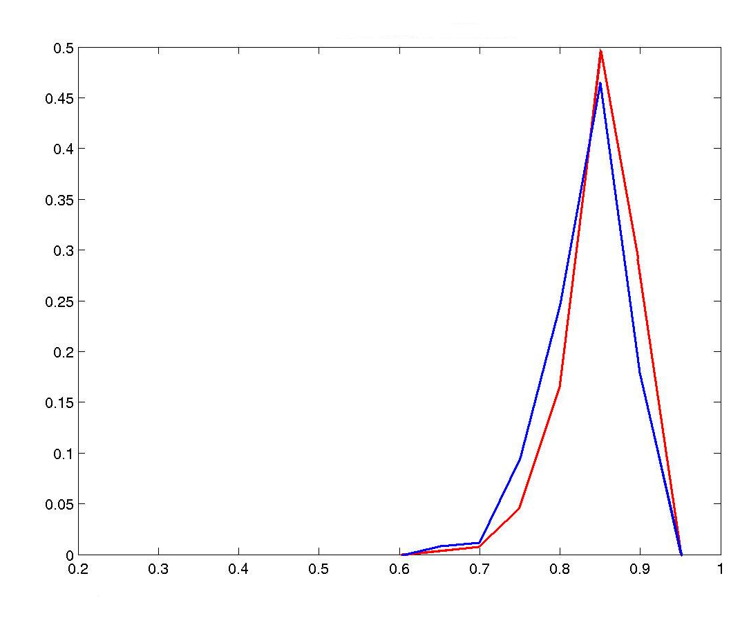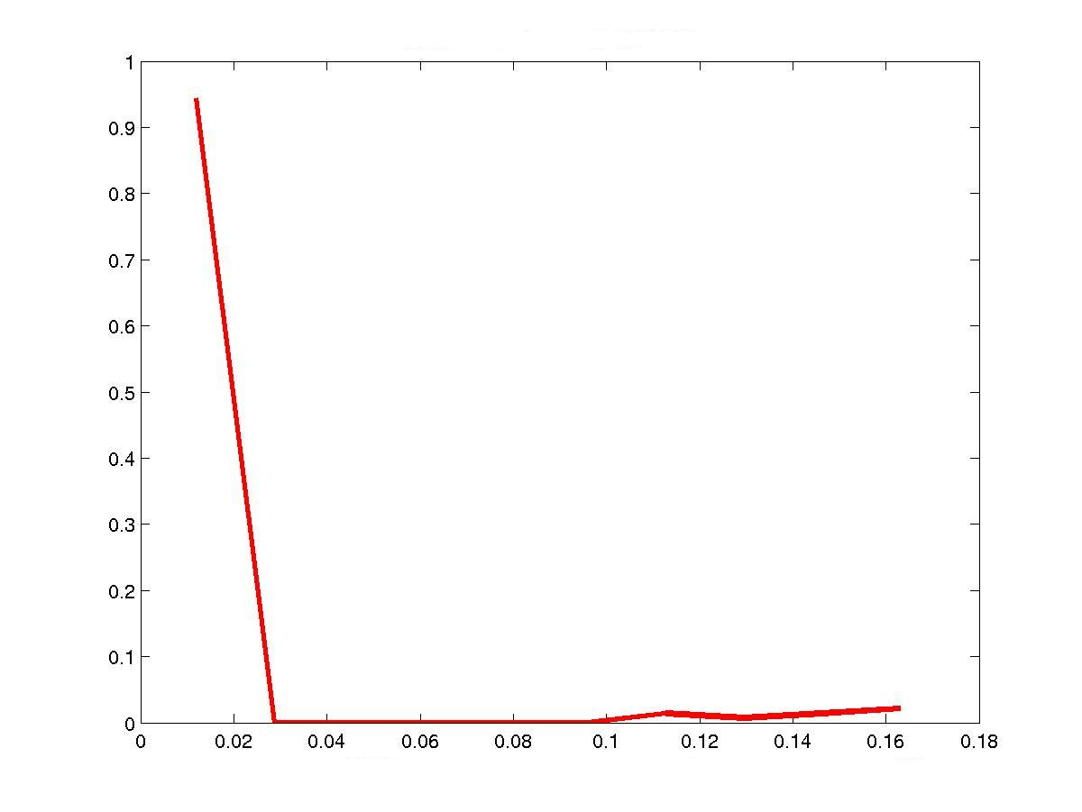
-a - - b –
- Figure 5 -
a) Distribution of the Dice coefficients for the right (red) and left (blue) hemispheres
b) Distribution of the Dice coefficients measuring the brainstem overlap

- Results

1- Sagittal plane

The computation of the Dice coefficient for the left and right hemispheres for the subjects tested in the Buckner data set shows that 6 of these subjects have a Dice coefficient lower than 0.7 (corresponding to a p value of about 0.05) at least for one of the two hemispheres. Five out of the six subjects were previously detected in the wm segmentation failure detection step: holes are present in the wm volumes, which reduces the overlap and causes the Dice coefficient to drop. (see figures 6-b and 6-c). For the last subject (010329_vc6536, Figure 6-a), some voxels of the right and left hemispheres have been labeled as “wm hypo intensities” (77) in the subcortical stream. Because no laterality information is available for this label, the corresponding voxels are not taken into account in the computation of the Dice coefficients even if they belong to the wm volume. The higher the number of wm hypo intensities voxels is, the lower the computed Dice coefficient will be.

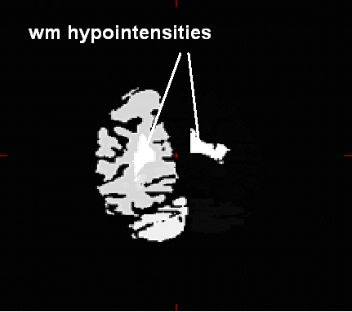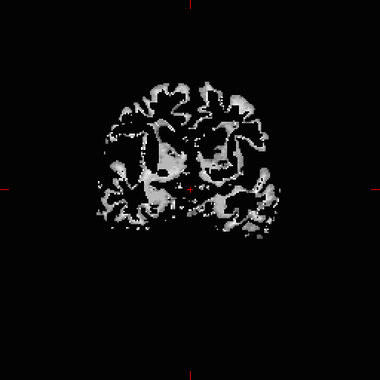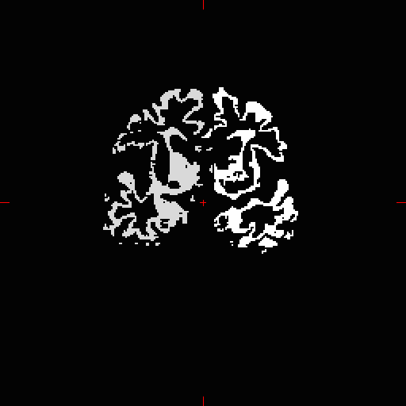
- a - - b - - c -

- Figure 6 -
a) aseg volume for subject 010329_vc6536 containing wm hypointensities labels (dr=0.67, dl=0.66).
b) and c) wm and filled volume for subject 010530_vc6952 (dr=0.17, dl=0.15)

According to the results described here above, checking the result of the wm segmentation in an earlier stage should leave this check to the vertical plane location.

2- Axial plane

For 8 subjects in the Buckner data set, the Dice coefficient measuring the overlap between the brain stem and the remaining white matter volume is too high which reveals a failure in the estimation of the locations of the pons and axial plane. The following images show the filled volume of a subject where the removal of the brain stem and cerebellum has not been correctly completed compared to a subject where this removal has been successful:


- a - - b -
- Figure 7-
Unsuccessful removal of the brain stem for subject 000904_vc5096 (dice coefficient = 0.1299) compared to a complete removal for subject 010130_vc6126. (dice coefficient = 0.0132)

V – Cortical Ribbon Placement

- Method

The surface-based stream creates surfaces at the interface between the white and cortical gray matter (the white surface), as well as on the boundary between the cortical grey matter and the pia (the pial surface). The space delimited by these two surfaces corresponds to the cortical mantle. This cortical mantle is also labeled in the subcortical labeling and the consistency between the two streams can be checked using a Dice coefficient.

The Figure 8 shows the distribution of the dice coefficients computed for 218 subjects in the Buckner training set:
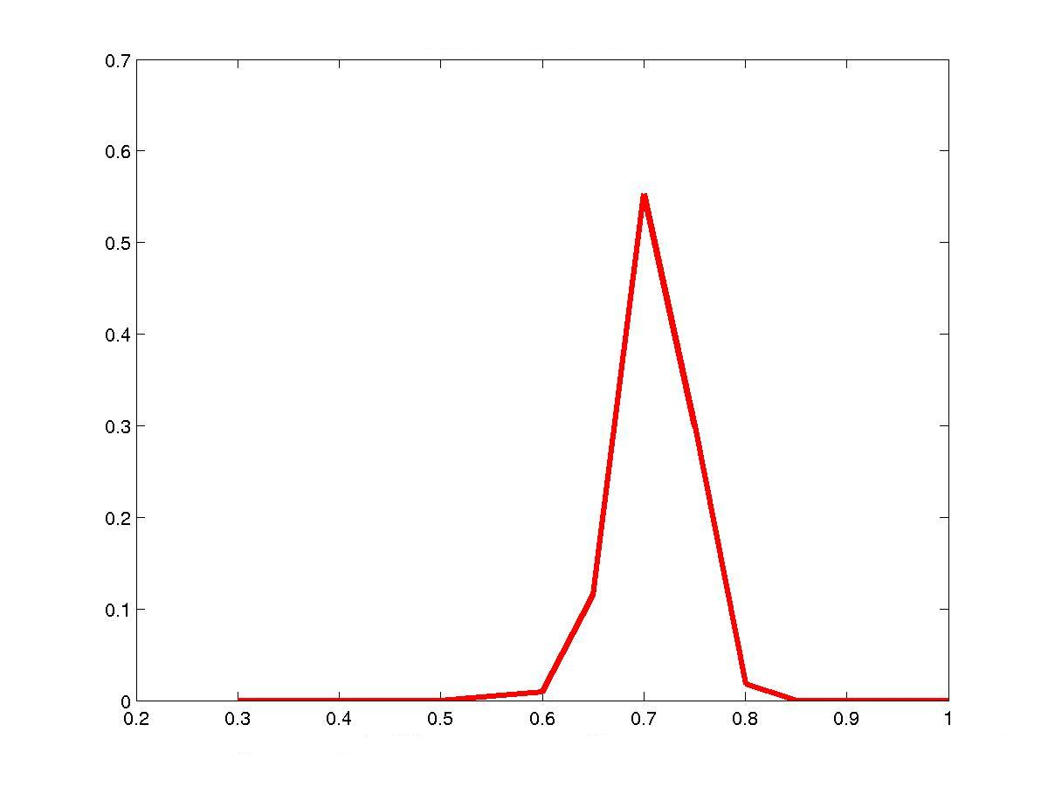
- Figure 8 -
Distribution of the Dice coefficients measuring the overlap between the voxels labeled as cerebral cortex and the volume delimited by the white and pial surfaces, based on 218 subjects of the Buckner data set.

This distribution shows that the average overlap between the cortical ribbons defined in the cortical and subcortical streams is about 70%. (Only the voxels labeled as left and right cerebral cortex have been taken into account for the cortical stream and differences in the definition of the cortical ribbon prevent the overlap of being larger).

- Results

Among the 218 subjects of the Buckner data set, 7 have a Dice coefficient smaller than 0.65. Two main reasons can be identified that cause the Dice coefficient to drop.

First of all, the volume between the white and pial surface is generated by creating a mask on the external side of the white matter surface where the intensity of all the voxels which distance to the white matter surface is smaller than the cortical thickness. The cortical thicknesses are previously computed and stored, but for 2 of the 8 subjects having a relatively low Dice coefficient the stored thicknesses happened to be very close to zero. This results in a very thin cortical ribbon and a reduced overlap with the cortical volume defined by the cortical stream… an example of this phenomenon is shown on Figure 9-a).

A reduced overlap can also happen when the volume between the white and pial surfaced include structures such as the brain stem or cerebellum. In this case, instead of being too thin the generated cortical mantled is too large as shown on Figure 9-b).

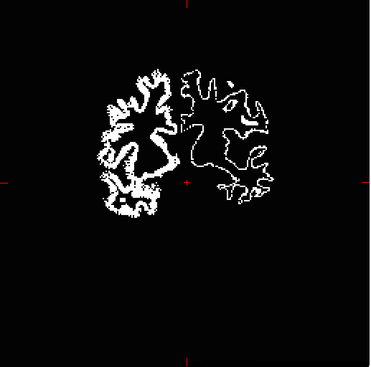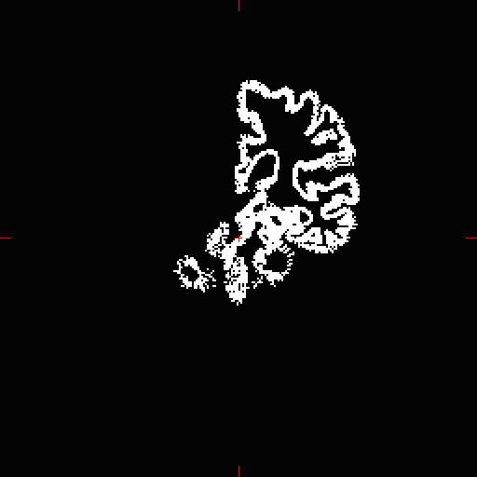
- a - - b -
- Figure 9 -
a) Subject 010223_61223: The cortical ribbon for the left hemisphere is very thin compared to the normal right hemisphere b) Subject 020107_vc8277: The cortical ribbon includes parts of the brain stem.

VI – Surface-based registration.

- Method

Each subject’s surface of the brain generated by the surface-based stream is aligned with an atlas in spherical space in order to map the values from subject-specific space into a common space. The registration is high-dimensional and non-linear. To test the registration, the thickness map of the subject is compared to the thickness maps of all the subjects in a training set.

Prior to the automatic failure detection, the thickness maps of the subjects in the training set have been assembled into a matrix. A singular value decomposition is performed and enough eigenvectors to explain 85% of the variance in the training set are extracted.

For a new subject, these extracted eigenvectors are used to compute the residual variance of the thickness map. The residual variance as a percentage of the original variance is used as a summary statistic. For a given subject, a relatively high residual variance shows that the training set cannot explain the patterns of its thickness map, which is the case if the registration failed. The distribution of the percent residual variance has been computed using 213 subjects of the Buckner data set and a jackknifing procedure in which the eigenvectors are computed for all but one subject. This distribution is shown on Figure 10:

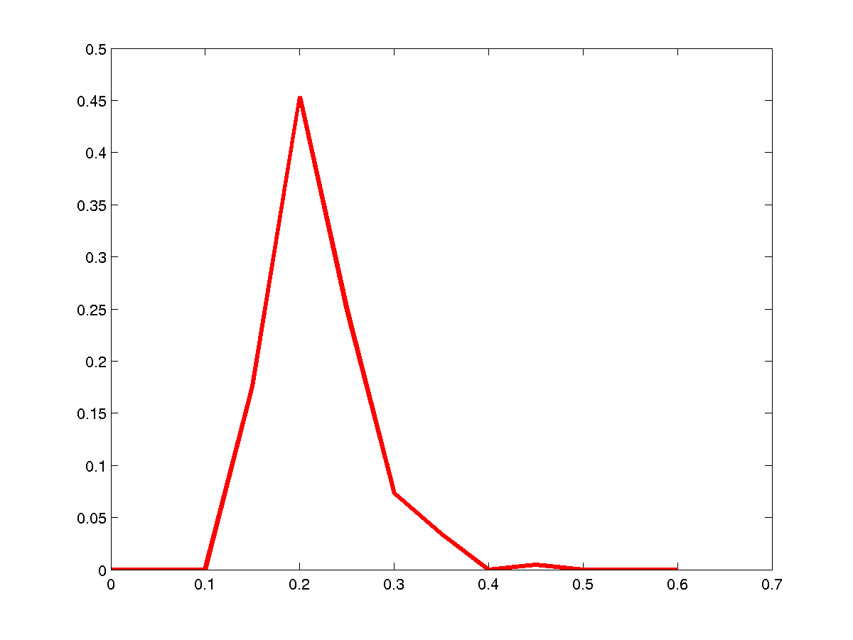
- Figure 10 -
Distribution of the percent residual variance of the thickness
computed from 213 subjects of the Buckner data set

On average, the percent residual variance is about 20%. A high residual variance should reveal whether any stage in the process that failed, but if the earlier stages have already been checked, this should indicate a failure in the surface-based registration.

In the Buckner data set, 15 out of the 213 subjects used have a residual variance higher than 30%.

VII – Cortical labeling

- Method

To test the cortical labeling, the surface area of each structure is used as a test statistic. For each label, the distribution of the surface area is computed over a training set. For a given subject, these distributions are used to compute the probabilities of the surface areas for all the labels enabling the detection of structures which area is out of the normal range.
The following figures show two examples of these distributions computed for the 84 labels using 135 subjects:
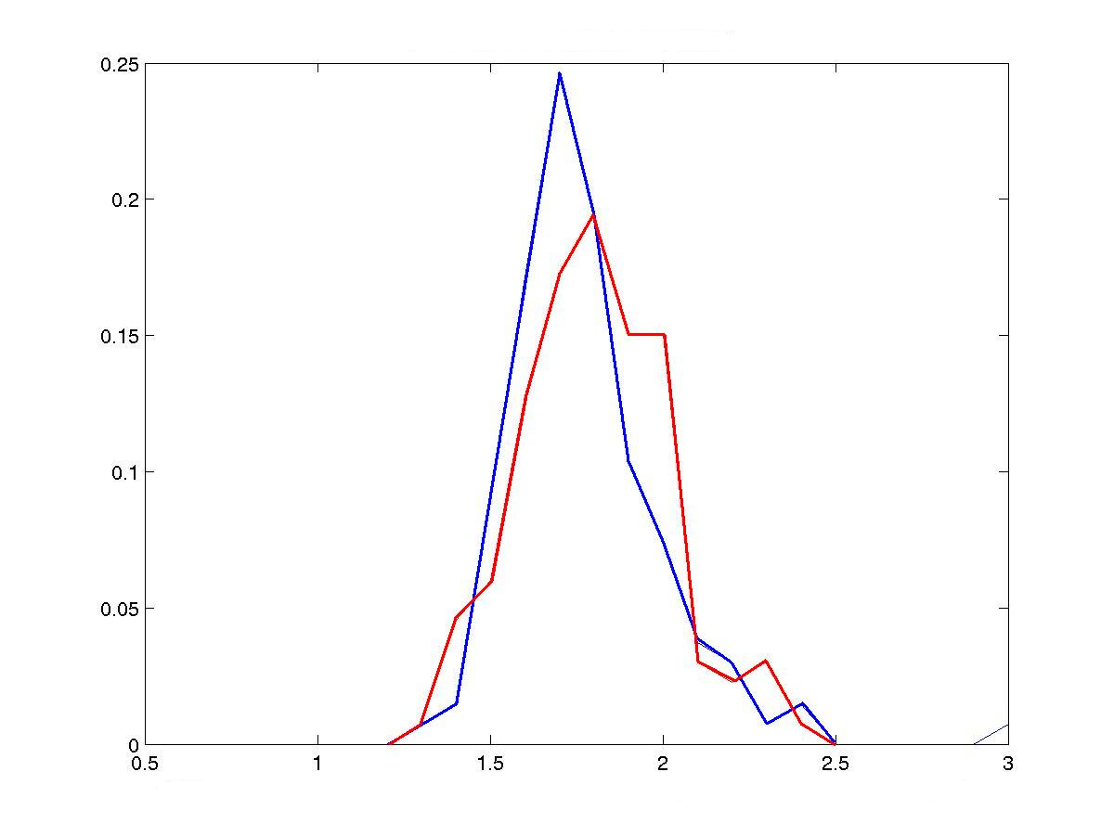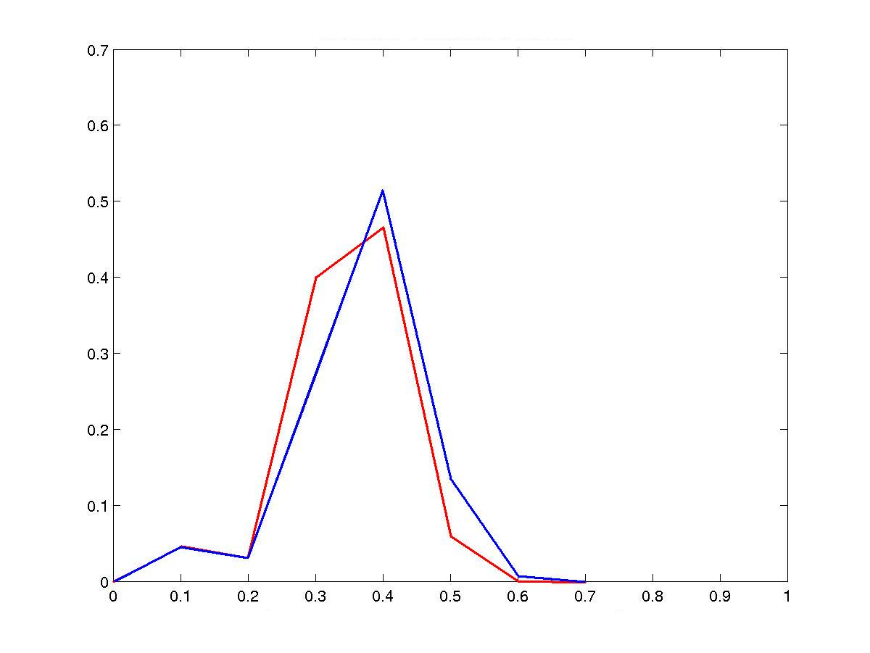
- a - - b -
- Figure 11 –
Distribution of the surface area for the left (red) and right (blue) hemispheres, for the structures labeled as G-precentral and S-orbital-medial

VIII – Subcortical labeling

- Method

In the volume-based stream, specific labels are assigned to the different structures of the brain. The volume of each structure is computed as a percentage of the whole brain volume over a training set. For twenty regions of particular interest, the distribution of these volumes is computed and used to detect the structures that have an abnormal size for a new subject.

The distributions of the percent volume of the brain have been computed for 20 labels and for 286 subjects in the Buckner training set.

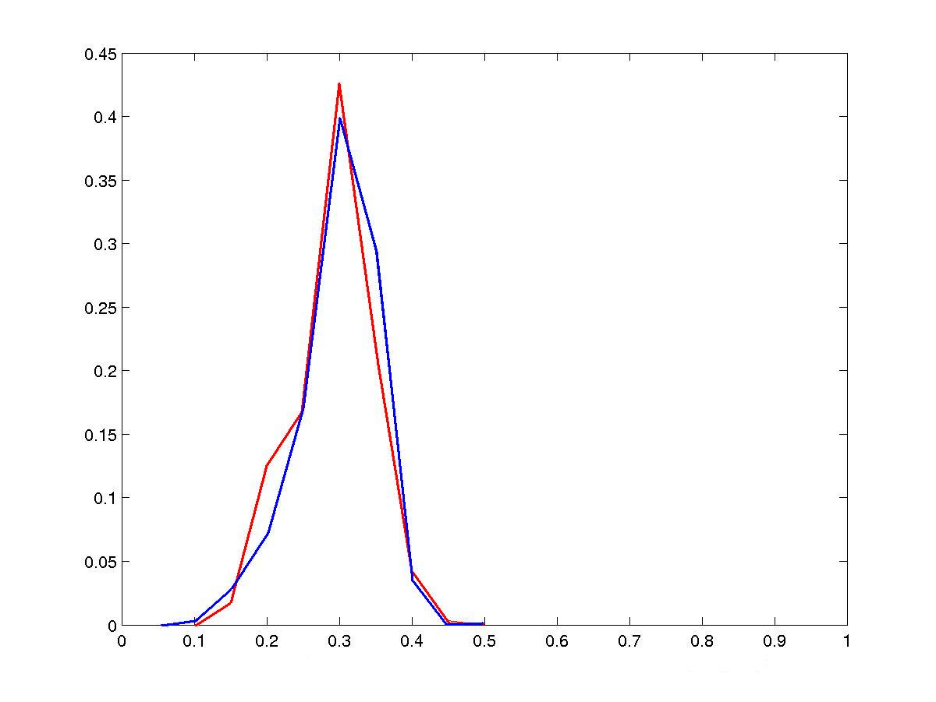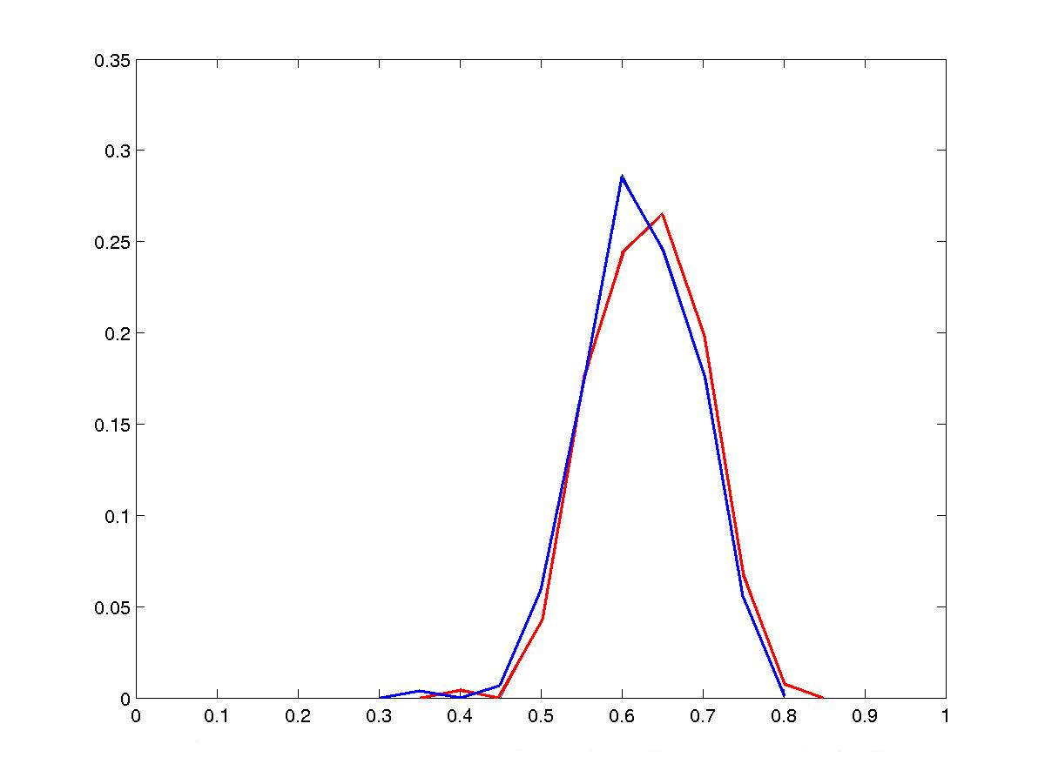
- a - - b -
- Figure 12 -
Distribution of the volumes labeled as hippocampus (a) and thalamus-proper (b) for the left (in red) and right (in blue) hemispheres, based on 286 subjects of the Buckner data set.

